**US Crime Data Exploration and Analysis**

1. **Creating a Database**

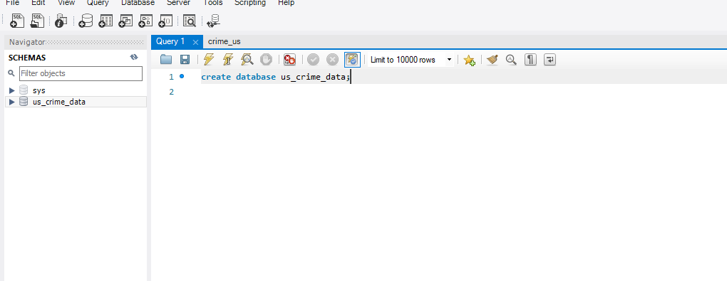

**2.Import Crime_us into the us_crime_data database**

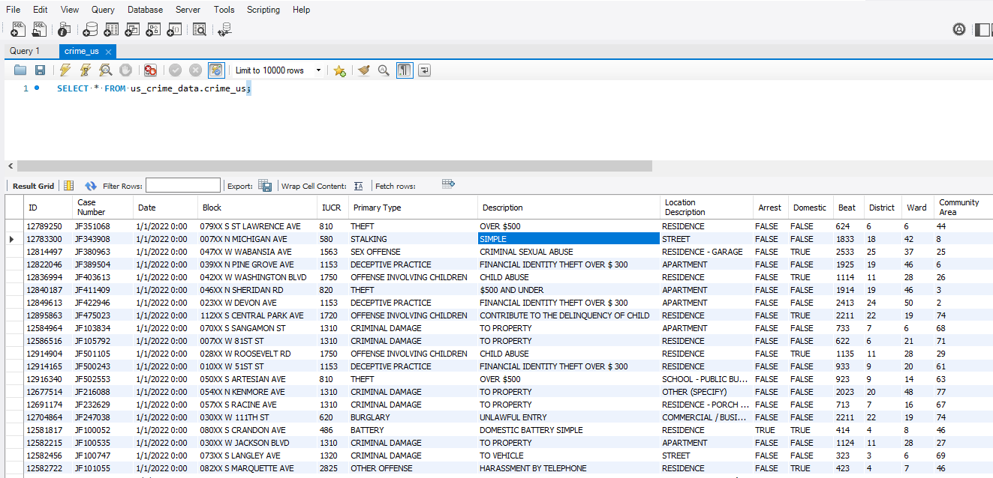

**It is required to delve deeper into data on different types of crimes and figure out the types of crimes which are more frequent and how they are trending over time.**

**Types of crimes:**

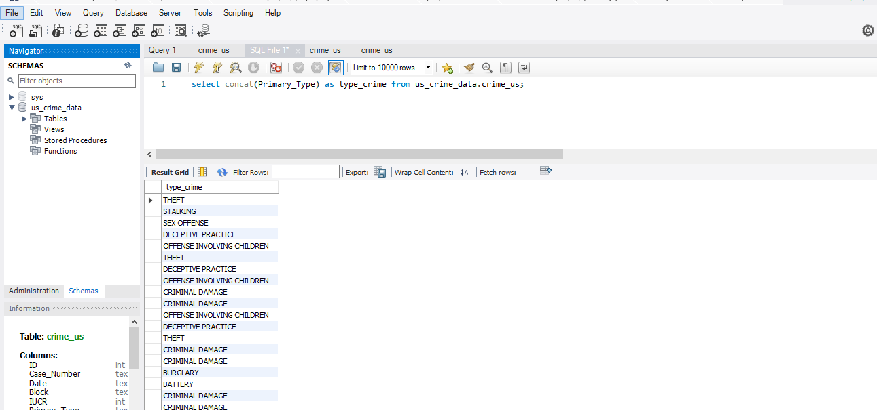

**Query for the most Frequent Crime:**

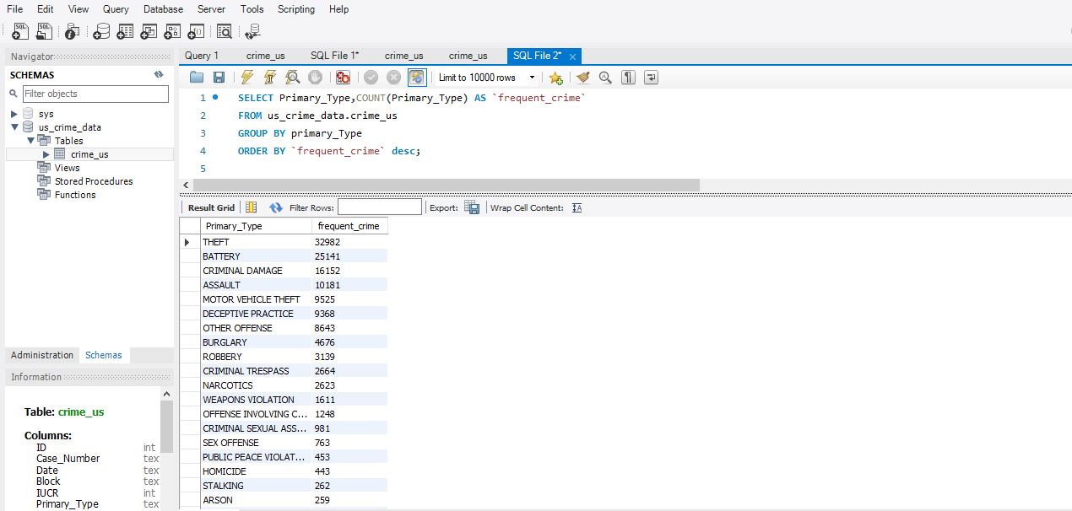

**Query for the most Frequent Crime and Location Description:**

